**Student Management Lab Session**

**Test Scenario 1:** Display Student Management Table

**Test Scenario 2:** Insert new records into the table:

Add Student “Daniel Warner” Department “B.Tech.” Country “New Zealand”

Click Submit

**Test Scenario 3:** Update existing records into the table.

Update “FirstName” for Student Id – 8 from “Muri” to “Murali”

Actual Output – Name updated to “Murali”

**Test Scenario 4:** Delete existing record from the table

Delete Student Id#3 “John” from table

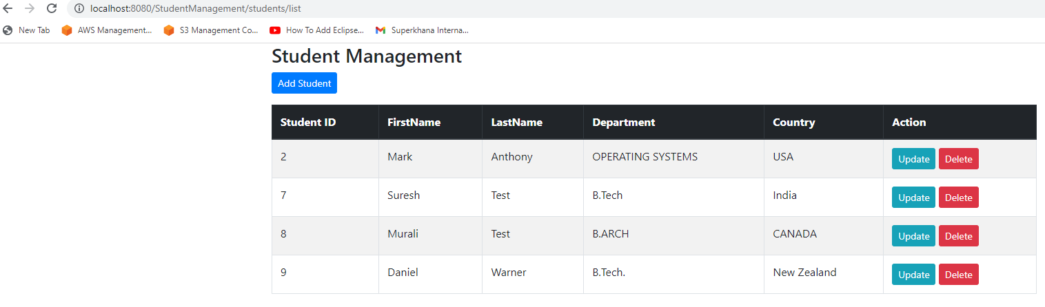

**Test Scenario 5:** Print all the records from the table.

